Methods & Attributes

📌 1. Attributes
# Source: AI Source: Provided by: [Data Path: Persons Table -> ID Column: 1, Name_En Column: Motasem Essam] -> From: [Chatgpt (GPT‑5 Mini)] on [12/9/2025]
Attributes (also called fields or properties) are the data or characteristics of a class or object.
- 🧩 Represent the state of an object
- 🏷️ Defined inside a class
- 🔒 Can have access modifiers (private, public, protected)

📌 Example (Attributes):
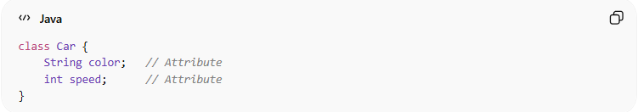
class Car {
String color; // Attribute
int speed; // Attribute
}

📌 2. Methods
# Source: AI Source: Provided by: [Data Path: Persons Table -> ID Column: 1, Name_En Column: Motasem Essam] -> From: [Chatgpt (GPT‑5 Mini)] on [12/9/2025]
Methods are functions or behaviors defined inside a class.
- ⚙️ Represent what an object can do
- 🧩 Operate on attributes or perform actions
- 🔒 Can have access modifiers

📌 Example (Methods):
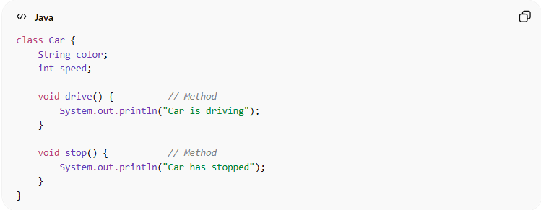
class Car {
String color;
int speed;

void drive() { // Method
System.out.println("Car is driving");
}

void stop() { // Method
System.out.println("Car has stopped");
}
}

🔍 Relationship:
# Source: AI Source: Provided by: [Data Path: Persons Table -> ID Column: 1, Name_En Column: Motasem Essam] -> From: [Chatgpt (GPT‑5 Mini)] on [12/9/2025]
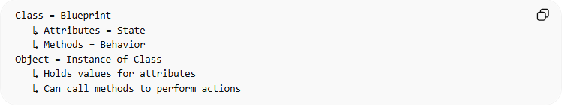
Class = Blueprint
↳ Attributes = State
↳ Methods = Behavior
Object = Instance of Class
↳ Holds values for attributes
↳ Can call methods to perform actions

🧠 Real-world analogy:
# Source: AI Source: Provided by: [Data Path: Persons Table -> ID Column: 1, Name_En Column: Motasem Essam] -> From: [Chatgpt (GPT‑5 Mini)] on [12/9/2025]
- 🏠 House = Class
- 🧱 Walls, doors, color = Attributes
- 🛠️ Open door, lock door, paint wall = Methods

🎯 Why attributes and methods are important:
# Source: AI Source: Provided by: [Data Path: Persons Table -> ID Column: 1, Name_En Column: Motasem Essam] -> From: [Chatgpt (GPT‑5 Mini)] on [12/9/2025]
- 🧩 Encapsulate state and behavior in objects
- 🔄 Support modular, reusable code
- 🧠 Form the core of object-oriented modeling

🎯 Summary:
# Source: AI Source: Provided by: [Data Path: Persons Table -> ID Column: 1, Name_En Column: Motasem Essam] -> From: [Chatgpt (GPT‑5 Mini)] on [12/9/2025]
Attributes store the state of an object, while methods define its behavior, making objects functional and meaningful in OOP.

